# Exercises: Java EE: Servlet API

Problems for exercises and homework for the [“Java Web Development Basics” course @ SoftUni](https://softuni.bg/courses/java-web-development-basics). Submit your solutions on the **course page** of the **current instance**.

We will implement a simple application, only with Servlets, exploring the most interesting exploits of the Servlet API.

# Chushka Application

Chishka is an application in which you create products, with several properties. It has many versions, and you will most probably see it several times.

You will have to create a simple multi-Servlet application which has several pages and 1 object entity.

# Data

This is the data layer of the application. There is 1 data object for you to implement.

So let’s create our Product. The Product is a data object which stores data about an abstract **product**. You will see later what it will be used for.

First implement a class Product – which has these properties:

* Name – a **String**.
* Description – a **String**.
* Type – can be one of the following values – (“Food”, “Domestic”, “Health”, “Cosmetic”, “Other”)

|  |  |  |  |
| --- | --- | --- | --- |
| Products | | | |
| Field | 1 | 2 | 3 |
| Name | Chushkopek | Injektoplqktor | Plumbus |
| Description | A universal tool for … | Dunno what this is… | A domestic tool for everything |
| Type | Domestic | Cosmetic | Food |

# Views

In this application you must create several views, similar to the pictures below:

# index.html

This is the home page, in other words the page that should be visualized when the application starts.

The index page must contain a button that redirect to **create-product.html** and **list all products names**. Upon clicking a name of a Product, you should be **redirected** to a **details page**, with **query parameter** – the name of the Product.

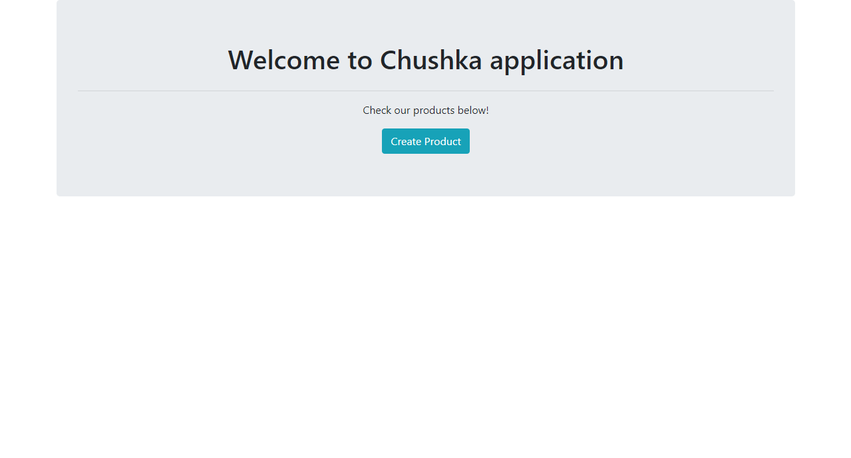

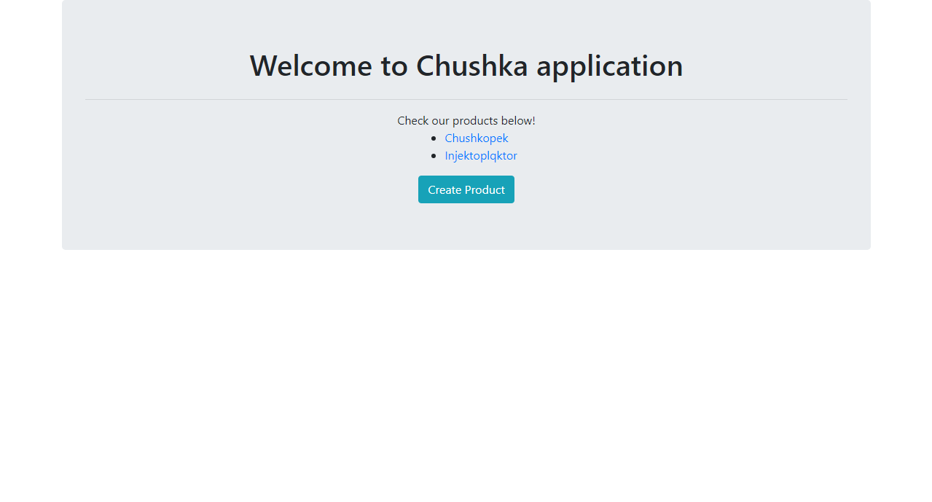

# create-product.html

This is the page where you create your products. It must contain **input** field for **name**, **textarea** for **description**, field for **selecting** the product’s **type**, **button** which creates a **Product** with the given values and a **link** that returns the **home** page.

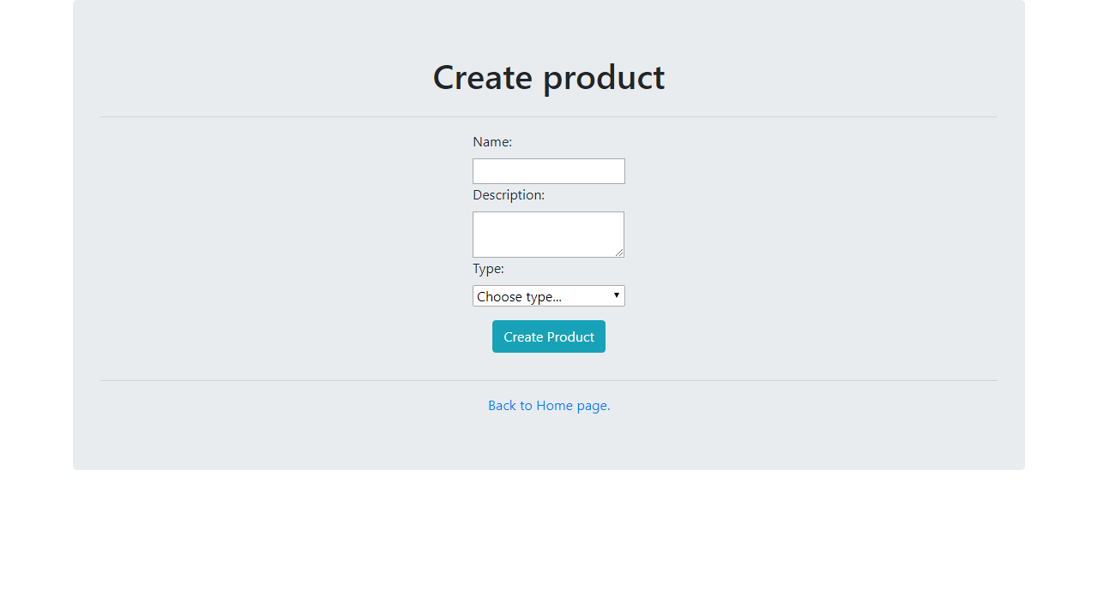

# details-product.html

This is the page which **renders full data** about the **selected Product**. The selected Product should be extracted from the database, using the name from the **query parameters**.

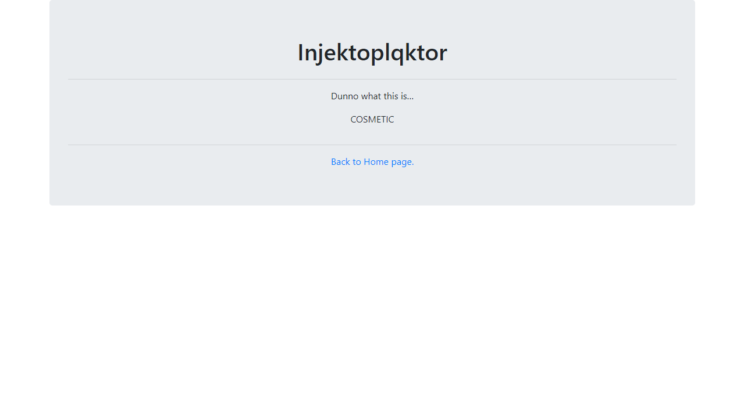

# Servlets

# Product Create

Implement a **Servlet** – ProductCreateServlet, which listens on route “/products/create”.

Upon a **GET** request, it should return a form which accepts **3 inputs** – a name, a description and a type.  
**NOTE**: You should only be able to submit “Food”, “Domestic”, “Health”, “Cosmetic”, “Other” as values for the type.

The **form** should send a POST request to the same route.

Upon a **POST** request, you should **redirect** to “/products/all”.

# Product All

Implement a **Servlet** – ProductAllServlet, which listens on route “/products/all”.

Upon a **GET** request, the **Servlet** should render a page with the names of all created Products. Upon clicking a name of a Product, you should be **redirected** to a “/products/details”, with **query parameter** – the name of the Product.

# Product Details

Implement a **Servlet** – ProductDetailsServlet, which listens on route “/products/details”.

Upon a **GET** request, the **Servlet** should extract the Product with the given name in the **query parameters**, and render a page with **full information** about it.

# Constraints

You must use the following things while implementing your application:

* Servlets
* Hibernate
* Repository layer
* Service layer
* Web layer